<!-- index.html (Home) -->
<!DOCTYPE html>
<html lang="en">
<head>
<meta charset="UTF-8" />
<title>Lakshya | Home</title>
<link rel="stylesheet" href="style.css" />
</head>
<body class="home-page">
<header>
<div class="logo">My <span>Portfolio</span></div>
<nav>
<a href="index.html" class="active">Home</a>
<a href="about.html">About</a>
<a href="skills.html">Skills</a>
<a href="contact.html">Contact</a>
</nav>
</header>

<main>
<section class="hero">
<div class="hero-text">
<h1>Hello, I'm <span>Lakshya</span></h1>
<h2>Front-End Developer & Problem Solver</h2>
<p>
I build responsive and user-friendly web experiences using
modern HTML and CSS.
</p>
<a href="contact.html" class="btn-primary">Hire Me</a>
</div>
<div class="hero-card">
<p class="tag">Available for Projects</p>
<p class="hero-small">
Passionate about crafting smooth UI and pixel-perfect designs.
</p>
</div>
</section>
</main>

<footer>
<p>© 2025 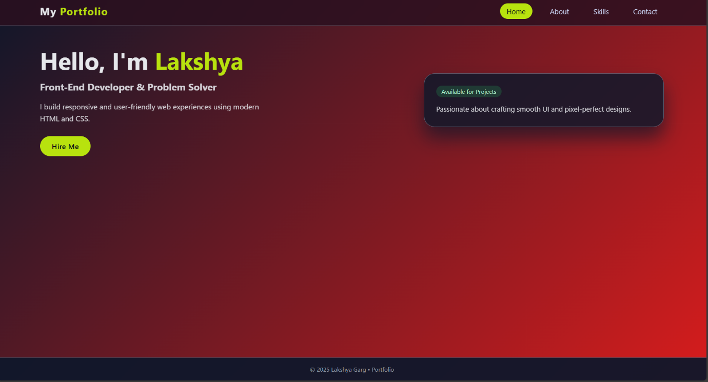 • Portfolio</p>
</footer>
</body>
</html>
<!-- about.html (About) -->
<!DOCTYPE html>
<html lang="en">
<head>
<meta charset="UTF-8" />
<title>Lakshya | About</title>
<link rel="stylesheet" href="style.css" />
</head>
<body class="about-page">
<header>
<div class="logo">My <span>Portfolio</span></div>
<nav>
<a href="index.html">Home</a>
<a href="about.html" class="active">About</a>
<a href="skills.html">Skills</a>
<a href="contact.html">Contact</a>
</nav>
</header>

<main>
<section class="content-section">
<h1>About Me</h1>
<div class="two-column">
<div>
<p>
I'm a passionate developer who enjoys turning ideas into reality
through code. I focus on writing clean, efficient, and accessible
front-end experiences.
</p>
<p>
When I'm not coding, I love exploring new technologies, learning
algorithms, and sharpening my problem-solving skills.
</p>
</div>
<div class="about-card">
<h2>Quick Info</h2>
<ul>
<li>💻 Front-End Developer</li>
<li>📍 Based in India</li>
<li>📚 Constant Learner</li>
<li>☕ Fuelled by Coffee & Code</li>
</ul>
</div>
</div>
</section>
</main>

<footer>
<p>© 2025 Lakshya Garg • About</p>
</footer>
</body>
</html>
<!-- skills.html (Skills) -->
<!DOCTYPE html>
<html lang="en">
<head>
<meta charset="UTF-8" />
<title>Lakshya | Skills</title>
<link rel="stylesheet" href="style.css" />
</head>
<body class="skills-page">
<header>
<div class="logo">My <span>Portfolio</span></div>
<nav>
<a href="index.html">Home</a>
<a href="about.html">About</a>
<a href="skills.html" class="active">Skills</a>
<a href="contact.html">Contact</a>
</nav>
</header>

<main>
<section class="content-section">
<h1>Skills & Tools</h1>

<div class="skills-grid">
<div class="skill-card">
<h2>Frontend</h2>
<ul>
<li>HTML5, Semantic Markup</li>
<li>CSS3, Flexbox, Grid</li>
<li>Responsive Design</li>
<li>Basic JavaScript</li>
</ul>
</div>
<div class="skill-card">
<h2>Tools</h2>
<ul>
<li>VS Code</li>
<li>Git & GitHub</li>
<li>Chrome DevTools</li>
<li>Vercel / Netlify</li>
</ul>
</div>
<div class="skill-card">
<h2>Strengths</h2>
<ul>
<li>Clean UI Design</li>
<li>Attention to Detail</li>
<li>Quick Learner</li>
<li>Problem Solving</li>
</ul>
</div>
</div>
</section>
</main>

<footer>
<p>© 2025 Lakshya Garg • Skills</p>
</footer>
</body>
</html>
<!-- contact.html (Contact) -->
<!DOCTYPE html>
<html lang="en">
<head>
<meta charset="UTF-8" />
<title>Lakshya | Contact</title>
<link rel="stylesheet" href="style.css" />
</head>
<body class="contact-page">
<header>
<div class="logo">My <span>Portfolio</span></div>
<nav>
<a href="index.html">Home</a>
<a href="about.html">About</a>
<a href="skills.html">Skills</a>
<a href="contact.html" class="active">Contact</a>
</nav>
</header>

<main>
<section class="content-section">
<h1>Contact Me</h1>
<p class="contact-intro">
Have a project in mind or just want to say hi? Drop a message below.
</p>

<form class="contact-form">
<div class="form-group">
<label for="name">Full Name</label>
<input id="name" type="text" placeholder="Enter your name" required />
</div>

<div class="form-group">
<label for="email">Email Address</label>
<input id="email" type="email" placeholder="Enter your email" required />
</div>

<div class="form-group">
<label for="subject">Subject</label>
<input id="subject" type="text" placeholder="Project / Collaboration" />
</div>

<div class="form-group">
<label for="message">Message</label>
<textarea id="message" rows="5" placeholder="Write your message..." required></textarea>
</div>

<button type="submit" class="btn-primary">Send Message</button>
</form>
</section>
</main>

<footer>
<p>© 2025 Lakshya Garg • Contact</p>
</footer>
</body>
</html>

